Joining and navigating each of the Committee rooms in the Zoom meeting

- On PC/Laptop go to the bottom of your Zoom screen (once connected to the meeting) and click on Breakout Rooms (see image below)
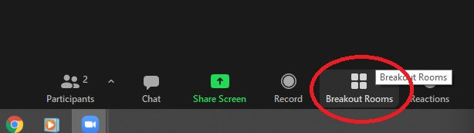
On Mobile Phone/Tablet (once connected to the meeting) click on Breakout Rooms in the top left corner of you screen (see image below)
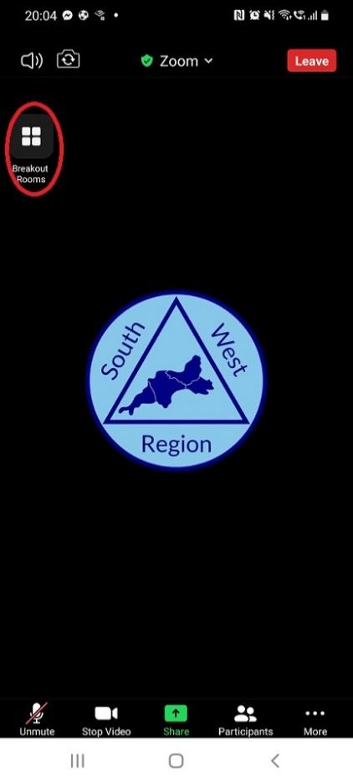
- On PC/Laptop a box will appear after clicking on Breakout Rooms listing the Committees available (1 – 6), click on the word ‘Join’ which corresponds with the Committee Room you wish to enter (see image below), a box will appear asking if you wish to join the Committee Room (see image below), select ‘Yes’ and after a short wait you will be entered into the Committee Room you have selected which will function like any other Zoom meeting you have taken part in

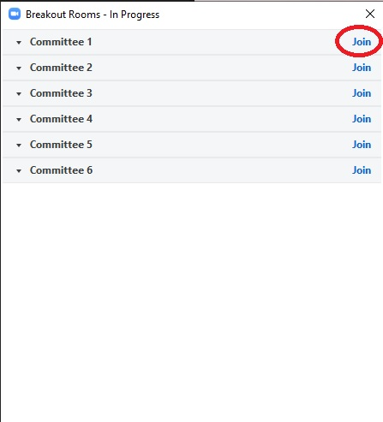
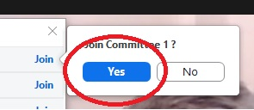
On Mobile Phone/Tablet the screen below will appear after clicking on Breakout Rooms listing the Committees available (1 – 6), click on (to highlight) the Committee you wish to join and then click ‘Join’, after a short wait you will be entered into the Committee Room you have selected which will function like any other Zoom meeting you have taken part in

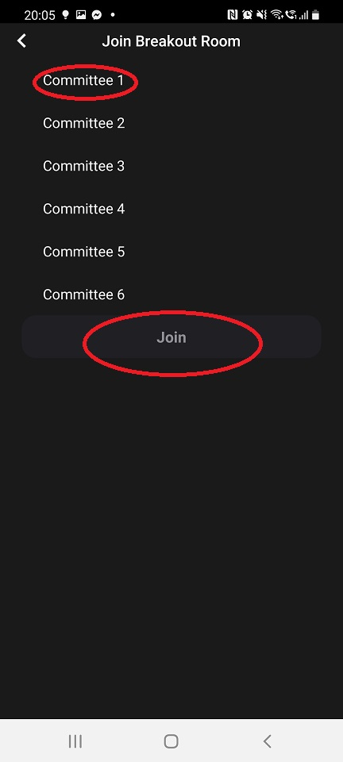

- On PC/Laptop to move to a different Committee Room, click on Breakout Rooms at the bottom of your Zoom screen (see image below) and repeat step 2 when the box with the list of Committee Rooms appears

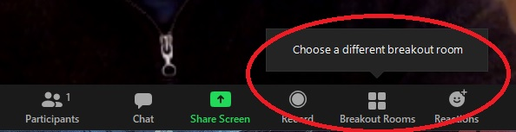

On Mobile Phone/Tablet to move to a different Committee Room, repeat step 1 and 2 and select the Committee Room which you wish to move to

- On PC/Laptop if you wish to return to the main meeting or leave the meeting entirely, click on ‘Leave Room’ in the bottom right corner of your screen (see image below), then click ‘Leave Breakout Room’ to return to the main meeting or ‘Leave Meeting’ to end you Zoom session and leave the meeting entirely (see image below)

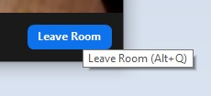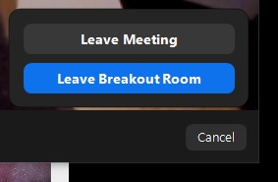

On Mobile Phone/Tablet if you wish to return to the main meeting or leave the meeting, click on Leave Room and then select either ‘Leave Breakout Room’ to return to the main meeting or ‘Leave Meeting’ to end your Zoom session and leave the meeting entirely (see image below)

